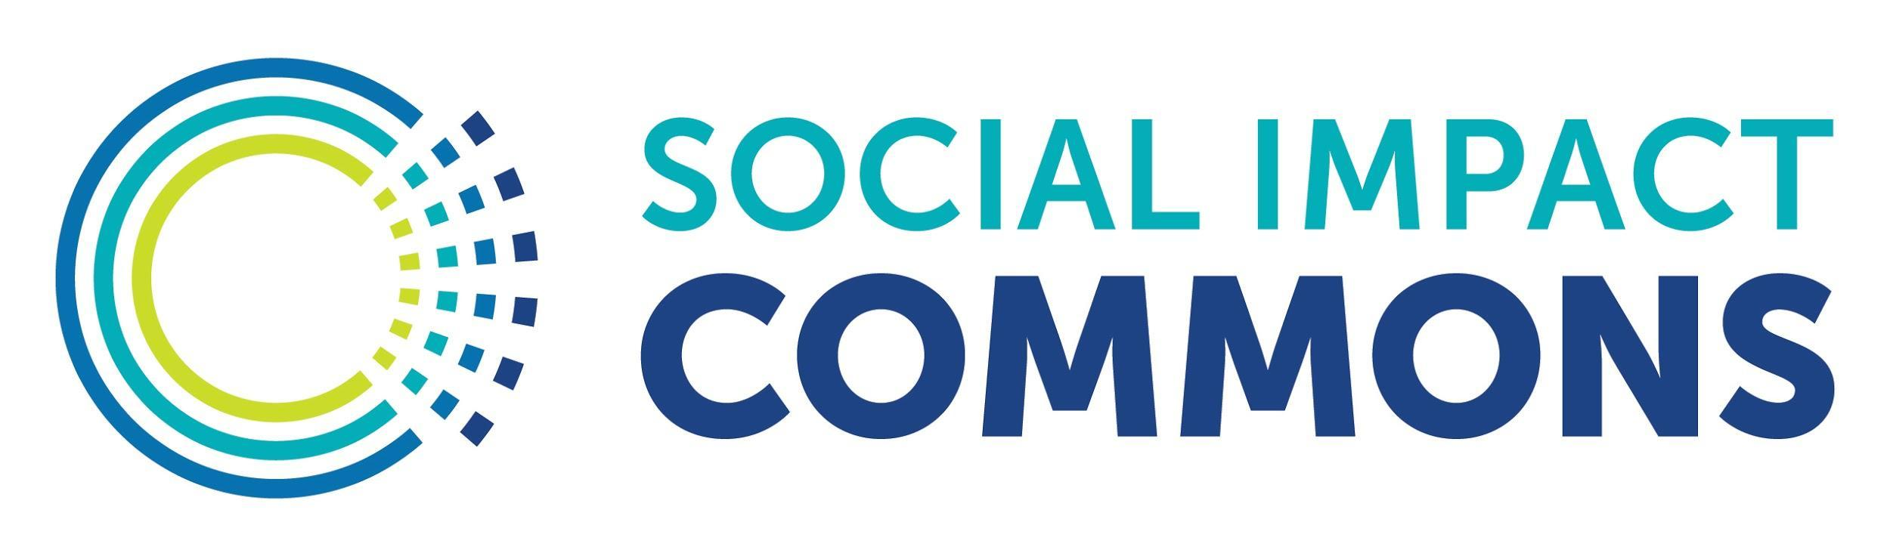

Summary Items for Board Approving ‘Model A’
Fiscal Sponsor Relationships
Version Date: June 30, 2022

What follows is a sample outline with some key items for fiscal sponsors to consider sharing with their boards when approving or ratifying new ‘Model A’ fiscal sponsorship relationships. We recognize that vetting and approval practices vary widely in the field and we identified these items as basic criteria for the board to understand regardless of whether they are formally approving a project or simply being informed.

Your use of this outline does not constitute legal advice from Social Impact Commons. Social Impact Commons is making this outline available for informational purposes only.

>>>You may remove this cover page for your use of this sample.<<<

Name of Project
Steering Committee Representative | May alternatively be called Project Board, Advisory Board or similar term
Project Director(s)
Website
Geographic Area(s)
Organization Status | E.g. startup, existing c3, “program of so and so”
Mission/Purpose Statement
Strategic Goals & Objectives
Notes on Budget & Fundraising
Notes on Key Risks & Mitigants
Operational/Capacity Considerations
Other Management Notes

