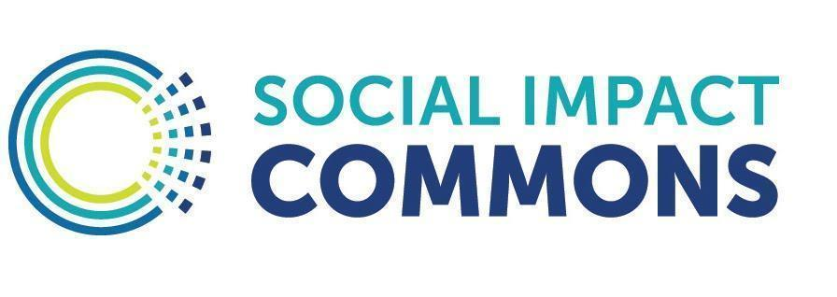
Patterns for Equitable Contracting

Below are design principles we take into account when constructing, negotiating, and entering into contracts. All contract templates contributed to the Commons Tools Library should embody these. This guidance will be periodically updated based on feedback from our Members.

- Table Setting: It is helpful to provide context around the missions and purposes of the parties and their intentions surrounding the engagement. We use recitals or background statements at the outset of the contract to communicate this important information.

- Smartly Organized. Well-written contracts can serve as handy reference guides to help understand and manage relationships. One should not have to sift through page after page of “legalese” to find the terms most frequently referenced by staff. The terms of a contract should be organized in a way to promote ease of use and we suggest separating the legal “boilerplate” language from the terms that matter most to stakeholders which are placed in an exhibit or at the beginning of the contract. These terms include the key timelines and milestones, designated contacts, description of who is doing what (i.e. the “scope”), and how and when money and/or other resources are exchanged. When the parties anticipate they may enter into a series of engagements over time, use a “master service agreement” where the parties agree to the general legal terms that will govern their overall relationships at the outset and then each time they wish to enter into a special engagement with one another, a simple sheet listing the key business terms is signed and becomes a part of the larger agreement.

- Use Definitions. If the contract will have words or phrases carrying special meaning used in multiple parts of the contract, add a definition section so there is a simple reference sheet that makes very clear what all of these terms mean. Capitalize those words or phases when they appear in the contract so the reader understands they are associated with the special meaning from the definition section.

- Fair Terms: Contracts should not be one-sided but rather have balanced key clauses including the following:
  - Notification. In general, each party should have a reasonable time to respond to concerns raised by the other party and an equitable process should be in place to address concerns. Sanctions and penalties, if any, should be graduated so as not to impose the maximum penalty on the first offense.
  - Indemnification. Each party should be responsible for its own actions and the maximum liability they can be exposed to should be in proportion to their responsibilities and the amount of funds being exchanged.
  - Disputes. Conflicts that can’t be resolved between and among the parties should be put to arbitration before any litigation process. Consider power dynamics and resources needed to travel and participate in any conflict resolution process when deciding on the venue for arbitrating or litigating conflicts.
  - Intellectual Property. When it comes to intellectual property such as copyrights, predominant and historical corporate thinking says the party paying should own the work product or have the exclusive right to use it for certain purposes. This “winner takes all” mindset is evolving for nonprofits and for-profits alike and it is worth considering opportunities to share ownership among the parties or making the work freely available to other stakeholders using licencing constructs such as Creative Commons or open source. Additionally, funding sources increasingly require their grantees share work produced with their grant funds with the general public; something to keep in mind.

- Gender Neutral: Contract language should be gender neutral referring to person or individual rather than assigning sex or sentences should be structured to eliminate pronouns completely. Also, when names of individuals are used, list them in alphabetical order.

- Plain Language: Phrases like “Notwithstanding the aforementioned” and “the party of the first part renders unto the party of the second part” add nothing beyond confusion and frustration to a contract. Legal drafting should employ short sentences, clear language, avoiding complex construction, and legal jargon, such as Latin terminology, and abbreviations. Contract sections and headers should be descriptive in terms understandable to an average person. Agreements should be available in the predominant language of all parties.

- Risk Appropriate Complexity: The complexity and length of agreements should be appropriate to the risk and relationship that the agreement is meant to govern, with the intention for agreements to be minimal in length and not “over-manage” from a legal standpoint.

- Clear Amendment & Equitable Exit: The manner in which the agreement may be changed or exited by either party should be clearly stated. And if exit or termination is the goal or possible eventuality, fair and balanced (not punitive) terms for all parties should be articulated.

- Practical Compliance: Compliance-related matters should be as simple to satisfy as possible, while serving the underlying purpose of the agreement--”over-compliance” should be avoided, or cumbersome compliance standards or methods, where simpler approaches would suffice.

- Values-aligned Subcontracting: In agreements where either party is permitted to engage subcontractors, there should be requirements that subcontractors comport with standards of fairness and sustainability in their business operations.

- Use of Attorneys. Groups making good use of this guidance and our Commons Tools Library should require less legal expertise as resulting contract structures and terms will be fairer and easier to understand than typical contracts. However, contract attorneys can still play an important role in thinking through and drafting solutions to complicated scenarios. When using attorneys to negotiate and/or draft contracts for you, we encourage you to share this sheet to ground them in our shared approach. If legal counsel has questions or suggestions to improve this guidance, we welcome the opportunity to engage.

