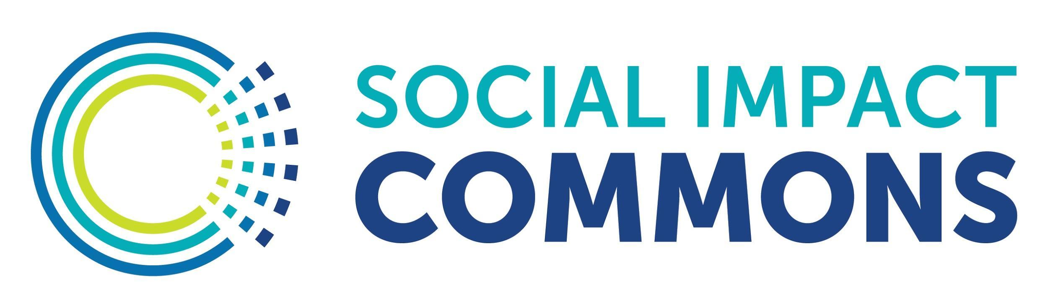

Readiness Factors for Model A Project Transitioning to Independent 501(c)(3)

In addition to 501(c)(3) tax-exempt status, ‘Model A’ fiscal sponsors provide critical back-office infrastructure to the projects they work with. When a project exits a ‘Model A’ fiscal sponsorship relationship, it is important that they develop their own capacity to independently steward the nonprofit program and its resources going forward. Below is a basic checklist of items the sponsor and leadership of the project may want to review together and decide what’s needed to launch the project as an independent organization.

- Incorporate/register under state laws
- Establish Board of Directors
- Receive 501(c)(3) determination from the IRS
- Set-up a bank account
- Establish financial system
- Draft policies and procedures
- Procure finance and accounting supports
- Set up Payroll management system
- Establish contracting practices & templates
- Purchase insurance (General Liability, Directors & Officers, Ect.)

