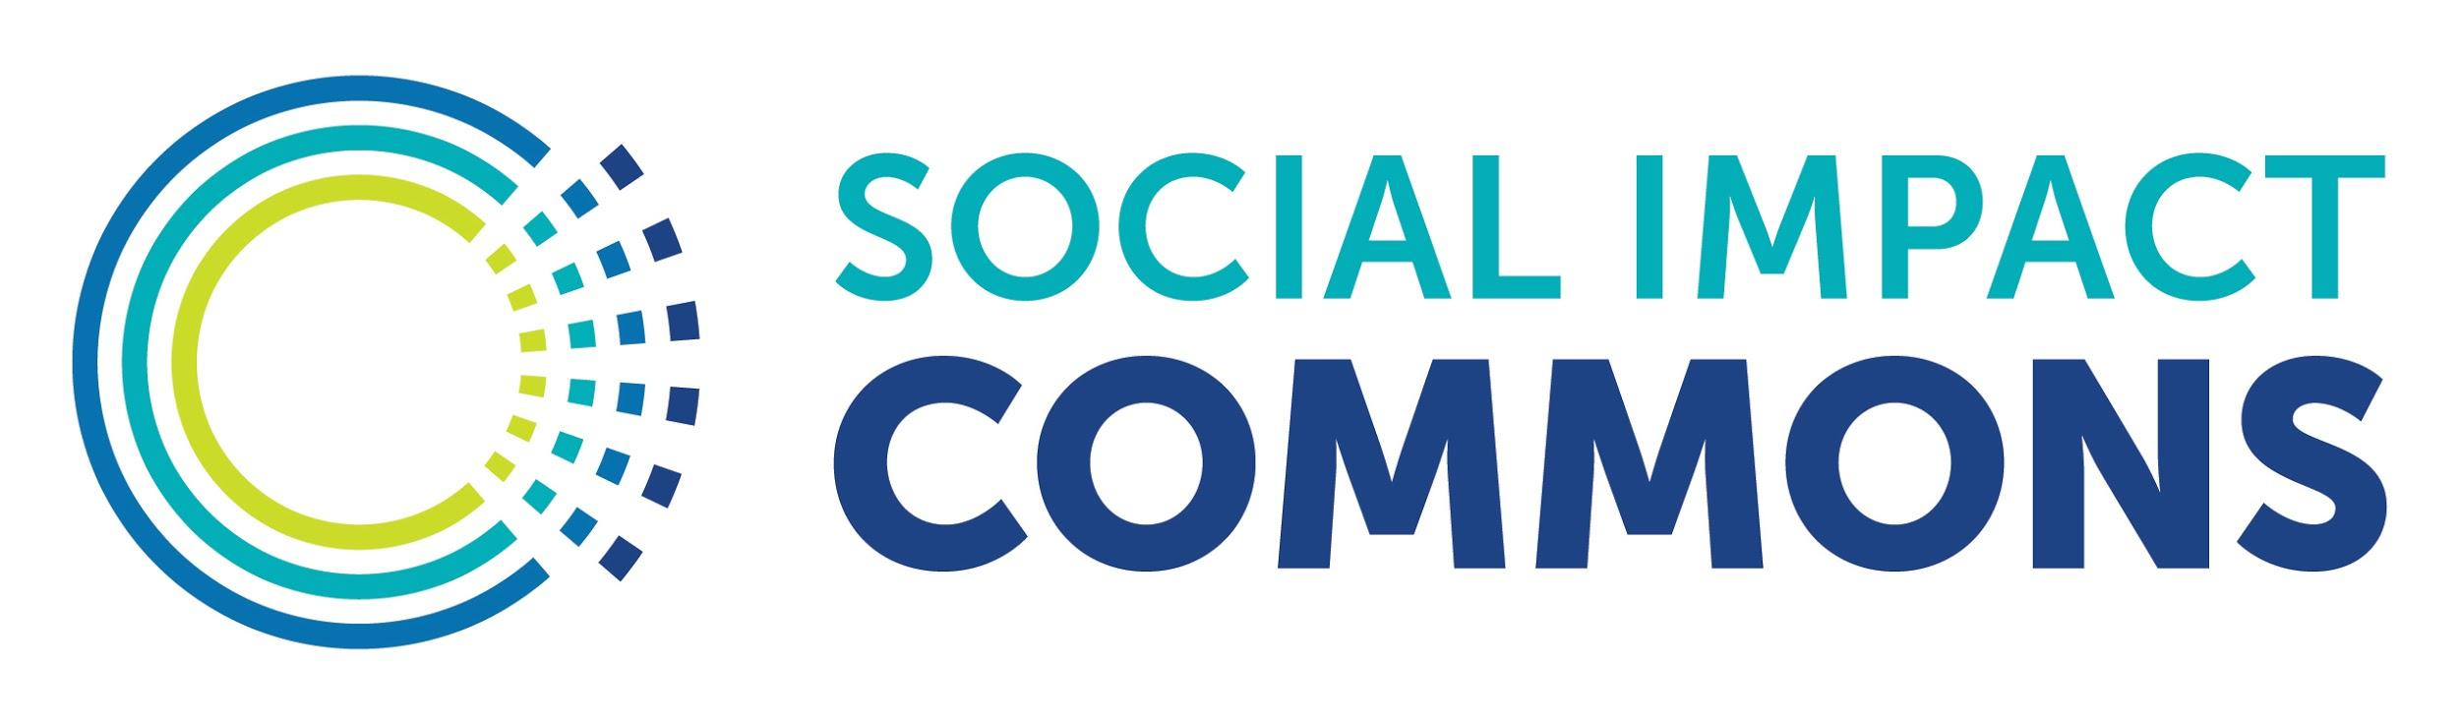

Key Definitions, Features, & Expectations of 'Model C' Fiscal Sponsorship Relationship

What follows is an example summary of some of the key terms of a ‘Model C’ fiscal sponsorship relationship between a 501(c)(3) public charity and a group or individual to fund and carry out a public benefit project of mutual interest. This document, inspired by guidance documents created by the Organizations and Transactions Clinic at Stanford Law School, is intended to be a companion to the ‘Model C’ Fiscal Sponsorship Agreement Template developed by Social Impact Commons in partnership with our member fiscal sponsors. This example may be freely modified by fiscal sponsors to help describe this type of relationship to potential partners, funders, and other interested parties.

Your use of this template provided by Social Impact Commons does not constitute legal advice. Social Impact Commons is making this example available for informational purposes only and we always recommend working with qualified and local legal counsel when structuring fiscal sponsorship relationships.

This work is licensed under a Creative Commons, Attribution- NonCommercial-ShareAlike 4.0 International Public License.

This means you can adapt this work and share its contents freely for non-commercial purposes, provided you credit Social Impact Commons in the event you share this template. Fiscal Sponsors do not need to credit Social Impact Commons when using this template to help structure ‘Model C’ fiscal sponsorship relationships.

>>>You may remove this cover page for your use of this template.<<<

Key Definitions, Features, & Expectations of 'Model C' Fiscal Sponsorship Relationship

The “Project Partner” | The entity or individual seeking charitable funds (grants & donations) to carry out a Project. If funded, this is the lead party in carrying out the Project.
The “Project” | A nonprofit initiative or activity the Project Partner proposes to carry out that will further the exempt purposes of the Fiscal Sponsor.
The “Fiscal Sponsor” | The public charity accepting and disbursing charitable funds to support the purposes of the Project.
Model C Fiscal Sponsorship Agreement | This is the agreement that establishes and governs the fiscal sponsorship relationship between the Project Partner and Fiscal Sponsor. It is critical both parties understand the agreement and are able to carry out their respectives roles and responsibilities.
Relationship Structure | The Fiscal Sponsor will submit grant applications prepared by Project Partner that Fiscal Sponsor approves and allow the Project Partner to solicit donations for the Project. Fiscal Sponsor will approve language used to raise funds and is the applicant on all grant applications. Fiscal Sponsor will directly receive all charitable funds prior to advancing to Project Partner to be expended to further the purposes of the Project. Please see the following page for a diagram of this type of arrangement.
Independent Parties | At all times, Project Partner and Fiscal Sponsor will remain independent parties and be responsible for their respective tax reporting obligations.
Communication | The parties will work closely with one another and each be responsive to questions and information requests of the other party. Each party will identify a primary point of contact to work with the other party.
Decision Making | Project Partner has broad discretion around strategic and program decisions in how the purposes of the Project are carried out. However, in order to ensure compliance with charitable laws and funder restrictions, Fiscal Sponsor retains ultimate discretion on how funds restricted to the Project are spent.
Reporting | Project Partner will provide activity reports to Fiscal Sponsor along with financial reports substantiating funds were spent as intended. Project Partner will also take the lead in preparing reports as may be required by funders. Fiscal Sponsor must review and approve the submission of all funder-required reports.
Compliance & Accountability | Both Fiscal Sponsor and Project Partner must comply with all applicable laws and donor conditions. Each Party is responsible for their actions.
Property Rights | Generally, property (including Intellectual Property) obtained or created in carrying out the Project will be owned by the Project Partner but must be used in a way that will continue to further the underlying charitable purposes of the Project, even once the Project is considered complete.
Cost Allocation | To defray the costs of Fiscal Sponsor providing support described in the Model C Fiscal Sponsorship Agreement, the Fiscal Sponsor will deduct a percentage of charitable funds it receives. That percentage is stipulated in the Model C Fiscal Sponsorship Agreement.
Ending the Relationship | The end date is defined in the Model C Fiscal Sponsorship Agreement to coincide with the contemplated completion date of the Project. Either party can end the relationship sooner by giving proper notice.

Some other terms often found in Fiscal Sponsorship Agreements or otherwise worth defining:
- Indemnification: One party agrees to compensate the other party for losses suffered as a result of the indenfigying party’s acts or omissions.
- General Liability / D&O Insurance: These are types of insurances to protect both the fiscal sponsor and the Project. General liability insurance provides the insured party with protection against claims resulting from injuries and damage to other people or property. Directors and Officers insurance protects the personal assets of corporate directors and officers, and their spouses, in the event they are personally sued for actual or alleged wrongful acts of the organization. In a “Model C” relationship, it may be necessary to procure separate Liability and D&O insurance policies to protect both the Fiscal Sponsor and the Project Partner.
- Private Benefit Rules: Embodied in three overlapping (and confusing) legal doctrines - 1.) the Private Benefit Doctrine; 2.) the Private Inurement Doctrine; and 3.) Excess Benefit Transaction Rules - these rules prevent the assets of nonprofits from unreasonably benefiting various parties. NEO Law Group provides quality primers on these legal doctrines Fiscal Sponsors should be familiar with.
- Variance Power: In this context, it is the discretionary power of the Fiscal Sponsor to use contributed funds for their intended purposes.
- Restricted Fund: Funds received by the Fiscal Sponsor on behalf of a Project are restricted to be used only in furtherance of that Project’s purposes. As such, these assets should not be subject to creditors or third party claims unrelated to the Project.
- Lobbying: Lobbying is generally defined as any activity that seeks to influence legislation. Nonprofits - and by extension Model C Projects - may engage in lobbying up to certain limits so long as upper-tier funders do not prohibit such activity and lobbying expenditures are tracked and reported on. Bolder Advocacy, a program of the Alliance for Justice is a great resource for nonprofits on the subject of lobbying and NEO Law Group provides targeted guidance on lobbying and grants to non-501c3 entities.
- Political Activity: Also called “electioneering” is directly or indirectly participating in, or intervening in, any political campaign on behalf of (or in opposition to) any candidate for elective public office. Unlike lobbying, there is a strict prohibition on 501(c)(3) nonprofit organizations engaging in any amount of political activity. Under no circumstances may Project Partners use Project funds to engage in political activity.

