Key Definitions, Features, & Expectations of 'Model A' Fiscal Sponsorship Relationship

What follows is an example summary of some of the key terms of a ‘Model A’ fiscal sponsorship relationship and the agreement that governs it. ‘Model A’ fiscal sponsorship is a term generally used to describe when a 501(c)(3) public charity partners with a group to carry out a public benefit project or program of mutual interest. Through this collaborative relationship, the fiscal sponsor provides a legal home, infrastructure, and administrative support to the project and the other group, which may be an unincorporated association, coalition, or even a legal entity, provides strategic guidance and oversight for the project. This document, inspired by guidance documents created by the Organizations and Transactions Clinic at Stanford Law School, is intended to be a companion to the ‘Model A’ Fiscal Sponsorship Agreement Template developed by Social Impact Commons in partnership with our member fiscal sponsors. This example may be freely modified by fiscal sponsors to help describe this type of relationship to potential partners, funders, and other interested parties.

Your use of this template provided by Social Impact Commons does not constitute legal advice. Social Impact Commons is making this example available for informational purposes only and we always recommend working with qualified and local legal counsel when structuring fiscal sponsorship relationships.
This work is licensed under a Creative Commons, Attribution-ShareAlike 4.0 International Public License.

This means you can adapt this work and share its contents freely for non-commercial purposes, provided you credit Social Impact Commons in the event you share this template. Fiscal Sponsors do not need to credit Social Impact Commons when using this template to help structure ‘Model A’ fiscal sponsorship relationships.

>>>You may remove this cover page for your use of this template.<<<

Key Definitions, Features, & Expectations of ‘Model A’ or ‘Comprehensive’
Fiscal Sponsorship Relationship

The “Steering Committee” | The legal entity or unincorporated nonprofit association or similar body entering into the agreement with the fiscal sponsor. This group is typically responsible for project-level governance and strategic support for the Project.
The “Project” | A nonprofit initiative or program being hosted by the fiscal sponsor and guided by the Steering Committee.
The “Fiscal Sponsor” | The public charity providing a 501(c)(3) home, infrastructure and a variety of support to help advance the purposes of the Project.
The “Project Director” | The individual or sometimes several individuals responsible for directing the Project. This role is akin to an executive director at a traditional standalone nonprofit. Typically this individual(s) becomes an employee of the fiscal sponsor.
Model A Fiscal Sponsorship Agreement | This is the agreement that establishes and governs the fiscal sponsorship relationship between the Steering Committee or Partner Organization entity and Fiscal Sponsor. It is critical both parties understand the agreement and are able to carry out their respectives roles and responsibilities.
Relationship Structure | The Fiscal Sponsor provides a legal home and back office infrastructure for a mission-aligned Project. As such, the Fiscal Sponsor typically holds all Project assets and is responsible for all liabilities associated with the Project. The Steering Committee in turn provides strategic guidance to the Project and holds certain rights and obligations defined in the Fiscal Sponsorship Agreement. Everyone works together to advance the purposes of the Project.
Support Provided by  Fiscal Sponsor | Corporate home. Fiscal Sponsor provides a corporate home for the Project and is responsible for the activities and liabilities of the Project.  Contracting - The Fiscal Sponsor enters into contracts on behalf of the Project.  Finances - The Fiscal Sponsor receives and expends funds on behalf of the Project and accounts for this activity.  Employment - The fiscal Sponsor is the employer of all staff working on Project matters.  Tax and insurance - The fiscal sponsor is responsible for all tax and regulatory filings, audit, and procures liability insurance  Other agreed upon support (e.g. fund development, advocacy work, succession planning)
Fundraising | Project representatives are responsible for fundraising and/or generating revenue to sustain the Project.
Communication | The parties will work closely with one another and each be responsive to questions and information requests of the other party.
Project Assets | While the fiscal sponsorship relationship is ongoing, all assets, including intellectual property, developed or acquired for the Project are owned by the Fiscal Sponsor and used exclusively to support the Project as directed by Project leadership.
Decision Making | In general, all strategic and programmatic decisions related to the Project are made by representatives of the Project, whether by the Steering Committee, Project Director, staff or volunteers. Projects should develop internal guidelines on how decisions are made. Because the Fiscal Sponsor is ultimately responsible for everything the Project does, it retains the right to disallow a Project decision if it is illegal or otherwise subjects the Fiscal Sponsor to unreasonable risk.
Policies & Procedures | Project staff are subject to the policies and procedures of the fiscal sponsor. The fiscal sponsor will train staff on key policies and update staff when policies change or new policies are added. If Project staff will be materially impacted, Fiscal Sponsor will solicit feedback when developing new or updating existing policies
Compliance & Accountability | The parties work closely together to ensure the Project is carried out in a compliant manner. The Fiscal Sponsor is ultimately responsible for the actions of the Project.
Cost Allocation | To defray the costs of Fiscal Sponsor providing support described in the Model A Fiscal Sponsorship Agreement, the Fiscal Sponsor will deduct a percentage of charitable funds it receives. That percentage is stipulated in the Model A Fiscal Sponsorship Agreement.
Ending the Relationship | Either Party can give notice to terminate the fiscal sponsorship relationship. When the fiscal sponsorship relationship ends, all funds and assets restricted for the Project typically are transferred to a successor entity identified by the Steering Committee and approved by the Fiscal Sponsor. This process requires numerous steps and close coordination between the Parties.

Some other terms often found in Fiscal Sponsorship Agreements or otherwise worth defining:
- General Liability / D&O Insurance: These are types of insurances to protect both the fiscal sponsor and the Project. General liability insurance provides the insured party (the Fiscal Sponsor and by extension, the Model A project) with protection against claims resulting from injuries and damage to other people or property. Directors and Officers insurance protects the personal assets of corporate directors and officers, and their spouses, in the event they are personally sued for actual or alleged wrongful acts of the organization.
- Private Benefit Rules: Embodied in three overlapping (and confusing) legal doctrines - 1.) the Private Benefit Doctrine; 2.) the Private Inurement Doctrine; and 3.) Excess Benefit Transaction Rules - these rules prevent the assets of nonprofits from unreasonably benefiting various parties. NEO Law Group provides quality primers on these legal doctrines Fiscal Sponsors should be familiar with.
- Variance Power: In this context, it is the discretionary power of the Fiscal Sponsor to use contributed funds for their intended purposes.
- Restricted Fund: Funds received by the Fiscal Sponsor on behalf of a Project are restricted to be used only in furtherance of that Project’s purposes. As such, these assets should not be subject to creditors or third party claims unrelated to the Project.
- Lobbying: Lobbying is generally defined as any activity that seeks to influence legislation. Nonprofits - and by extension Model A Projects - may engage in lobbying up to certain limits so long as upper-tier funders do not prohibit such activity and lobbying expenditures are tracked and reported on. Bolder Advocacy, a program of the Alliance for Justice is a great resource for nonprofits on the subject of lobbying.
- Political Activity: Also called “electioneering” Is directly or indirectly participating in, or intervening in, any political campaign on behalf of (or in opposition to) any candidate for elective public office. Unlike lobbying, there is a strict prohibition on 501(c)(3) nonprofit organizations engaging in any amount of political activity.

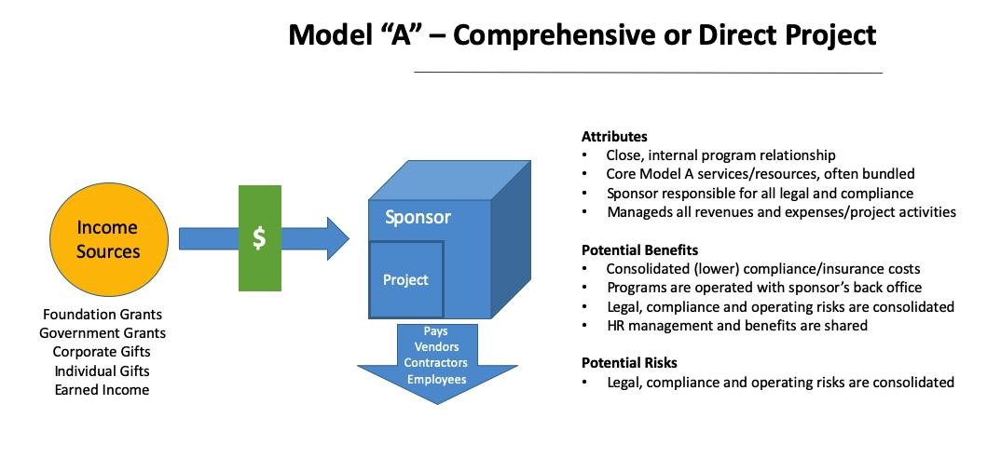

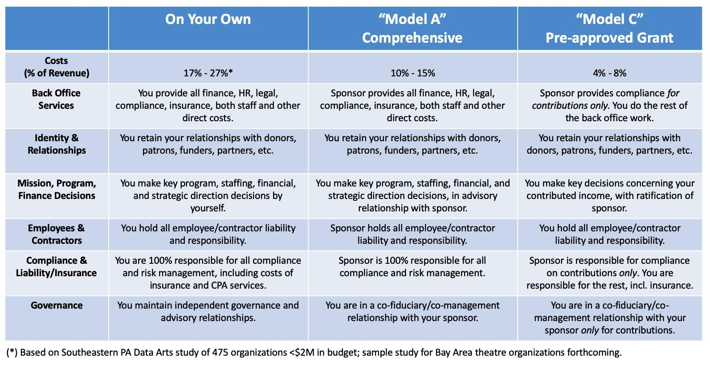

Labels such as “Steering Committee”, “Project” and “Fiscal Sponsor” are merely sample identifiers. Parties should use whatever identifying language works for them.

